**Class:** Final Year (Computer Science and Engineering)

**Year:** 2024-25 **Semester:** 1

**Course:** High Performance Computing Lab

**Practical No. 2**

**Exam Seat No: 21510074**

**Title of practical: Study and implementation of basic OpenMP clauses**

Implement following Programs using OpenMP with C:

1. Vector Scalar Addition
2. Calculation of value of Pi

Analyse the performance of your programs for different number of threads and Data size.

**Problem Statement 1:**

**Screenshots:**

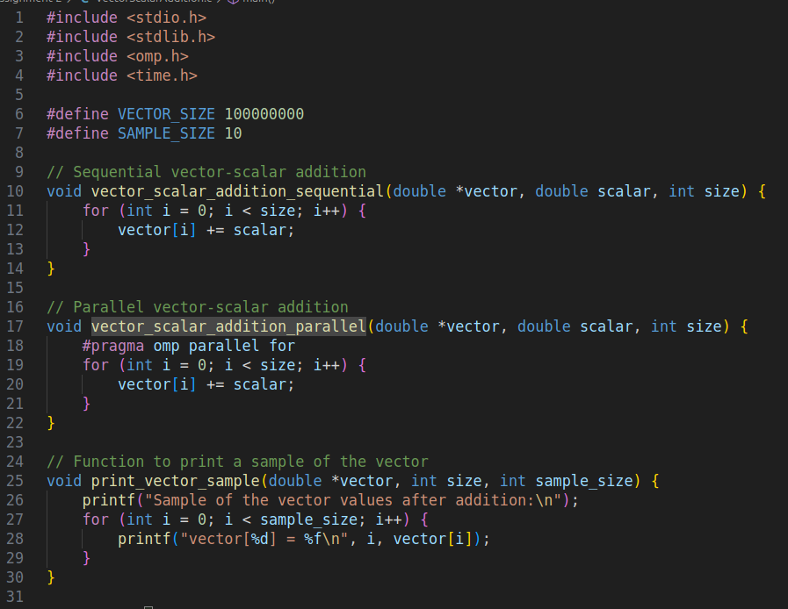

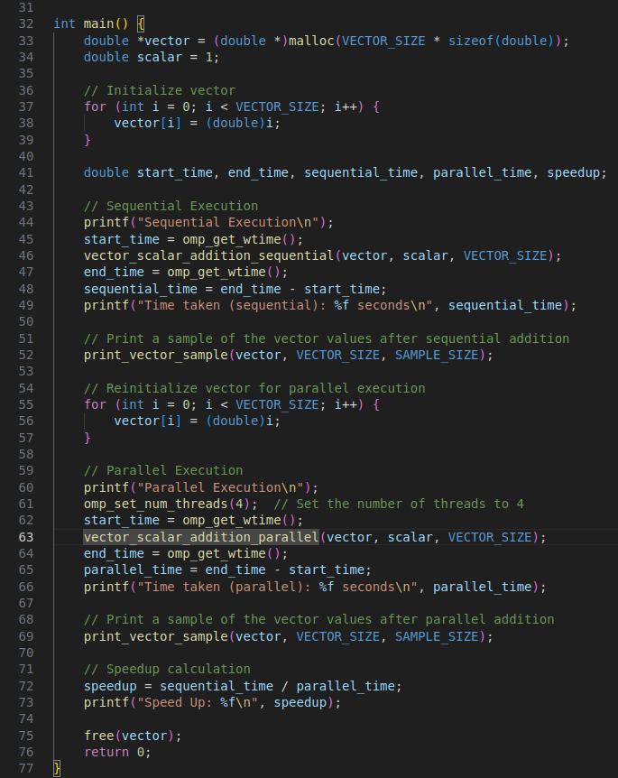

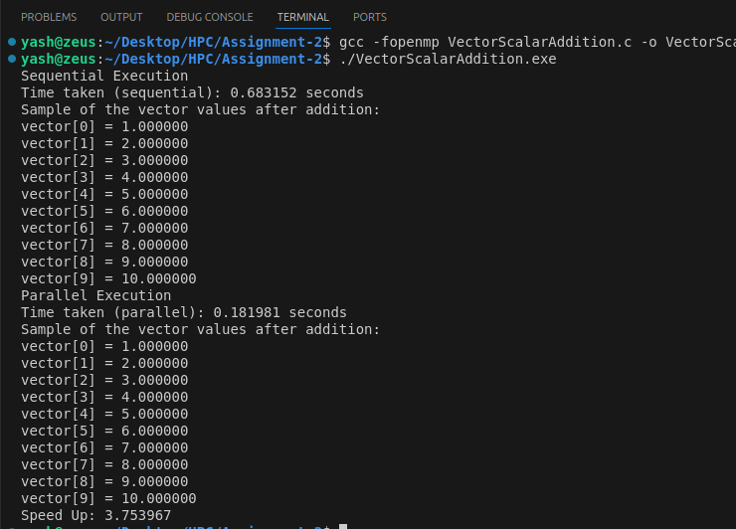

**Information:**

Execution time decreases up to 4 threads, then slightly increases for 8 threads.

Speedup calculation:

* 2 threads: 1.71x
* 4 threads: 2.35x
* 8 threads: 2.23x (performance degradation)

The performance improvement plateaus and slightly degrades at 8 threads, suggesting potential overhead or resource contention.

**Problem Statement 2:**

**Screenshots:**

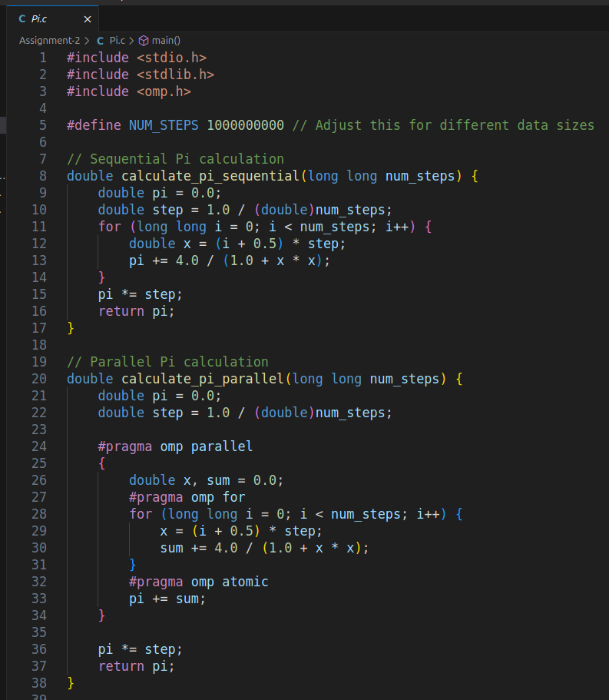

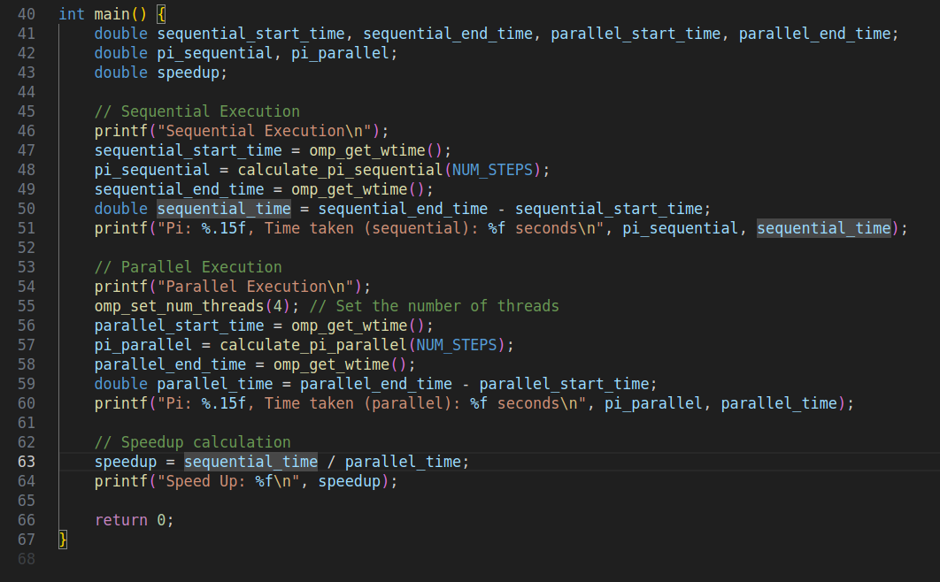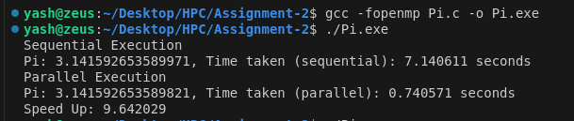

**Information:**

**Analysis:**

The execution time decreases as the number of threads increases.

Speedup calculation:

* 2 threads: 1.94x (near-linear)
* 4 threads: 3.59x (good scaling)
* 8 threads: 6.72x (still scaling well, but efficiency is dropping)

The calculated Pi value remains consistent across different thread counts, indicating correctness.

**Github Link:** <https://github.com/YashNawale26/High-Performance-Computing.git>